**Case 1-** Create Research Application(student tab)

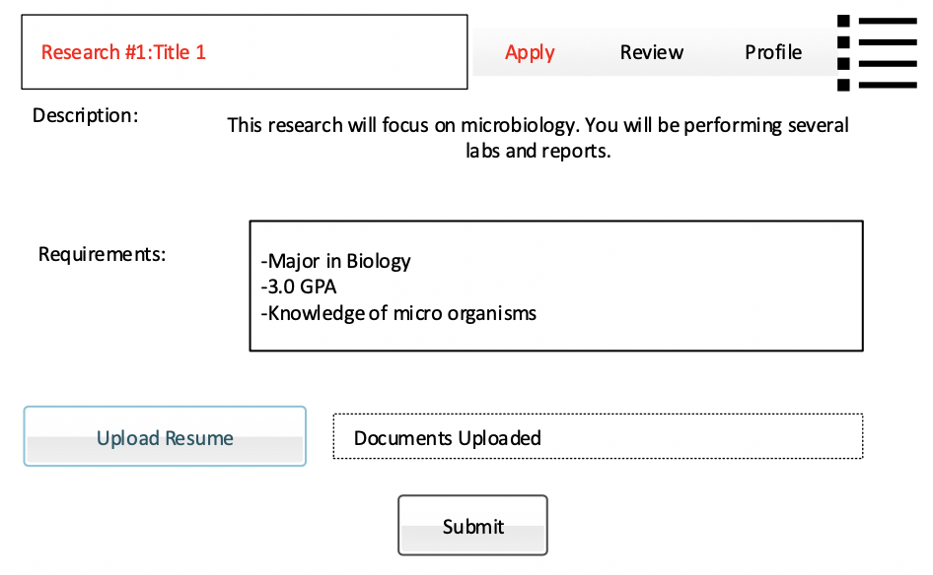

**Case 2-** Update Information on Current Partnerships (industry tab?)

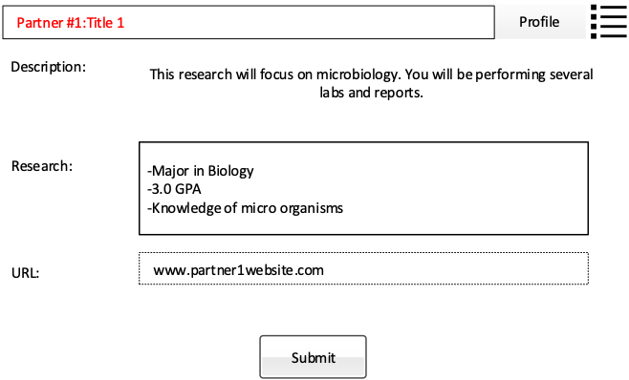

**Case 3-** Add weekly updates to Newsletter (News and Events tab)

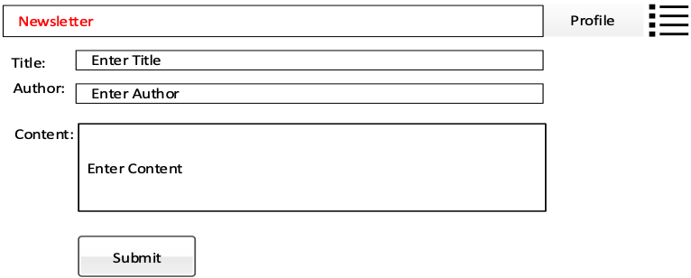

**Case 4-** Delete Newsletter (News and Events tab)

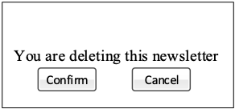

**Case 5-** Edit Newsletter (News and Events tab)



**Case 6-** Find Information Form

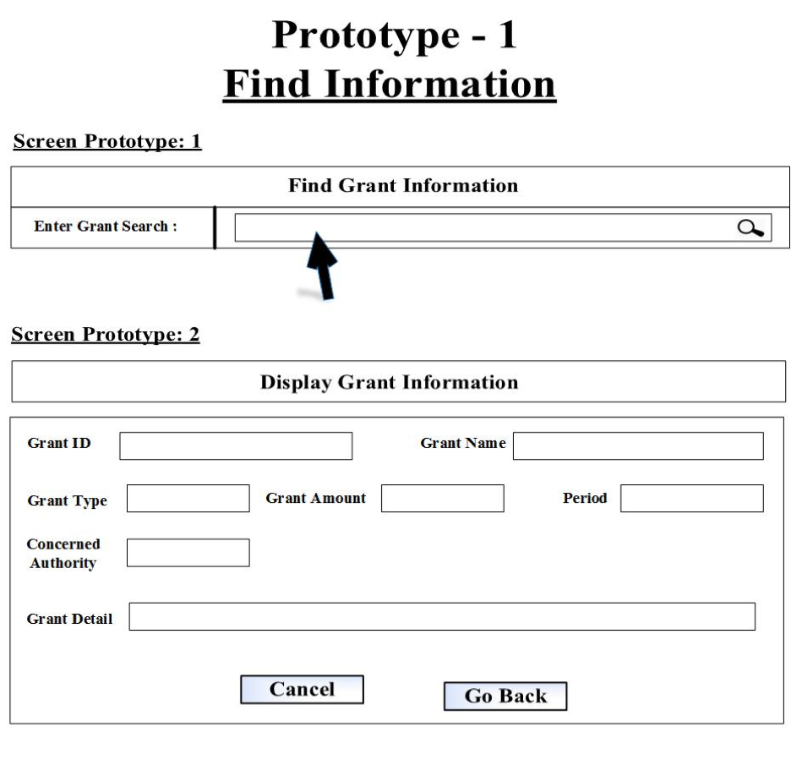

**Case 7-** Create Grants

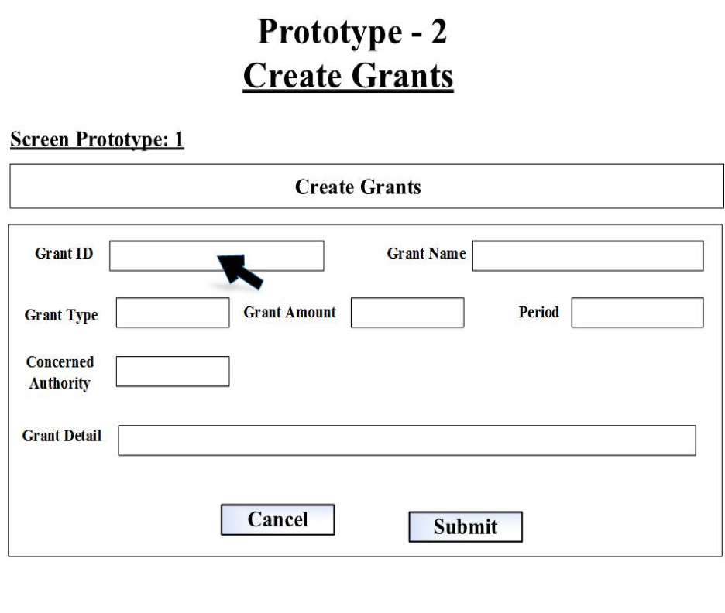

**Case 8-** Modify Grants

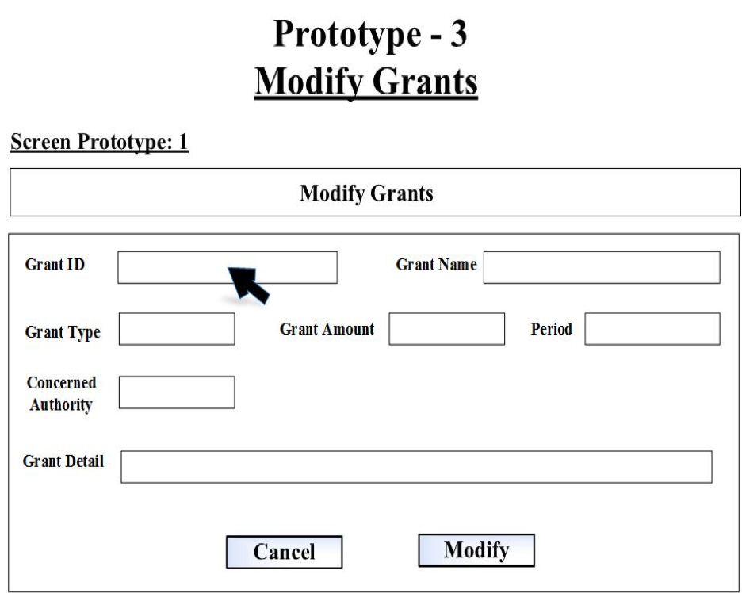

**Case 9-** Delete Grants

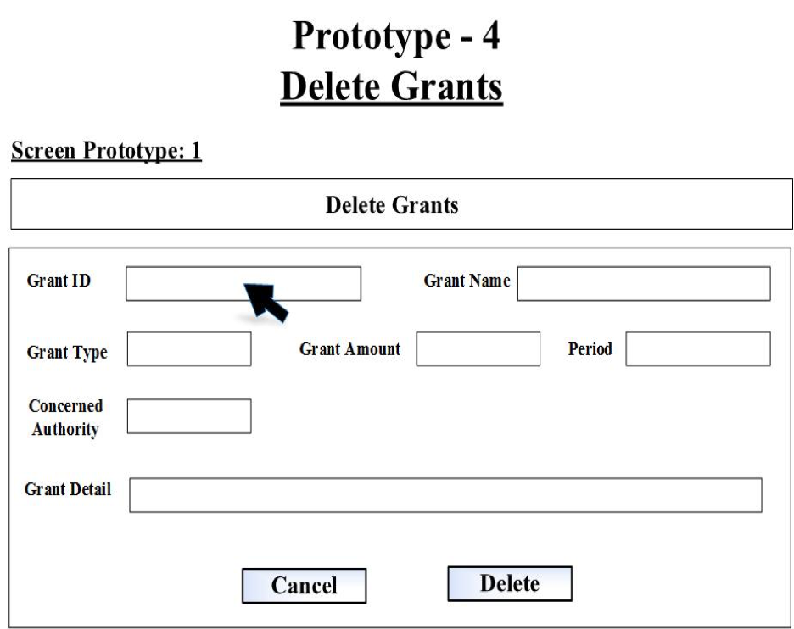

**Case 10-** Student Application Form (Student tab)

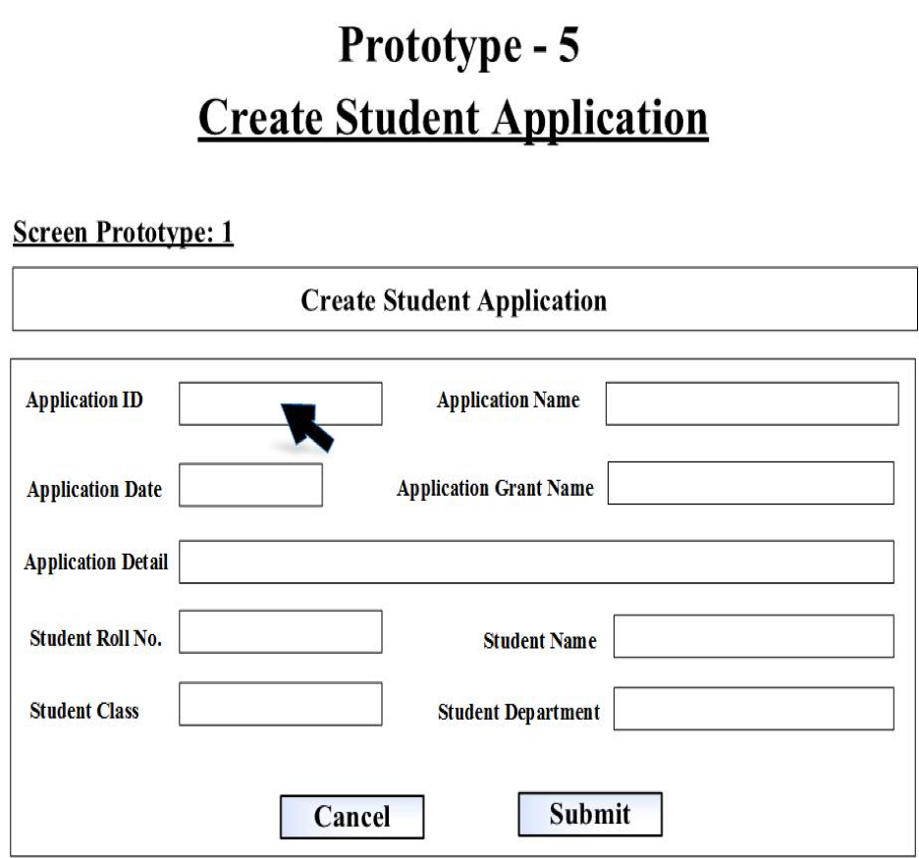

**Case 11-** Edit Student Application (Student tab)

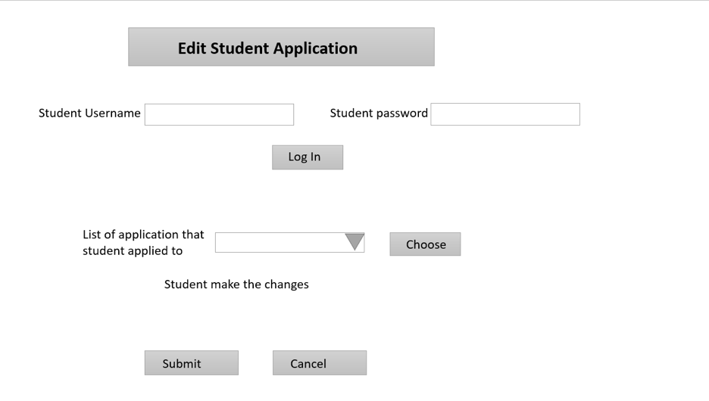

**Case 12-** Delete Student Application (Student tab)

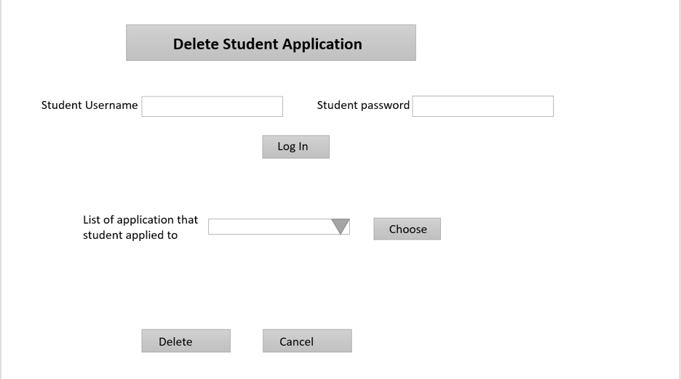

**Case 13-** Create Funding Application (Researcher tab)

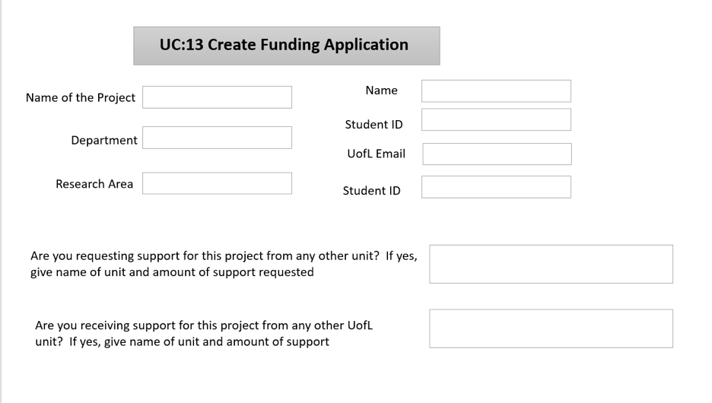

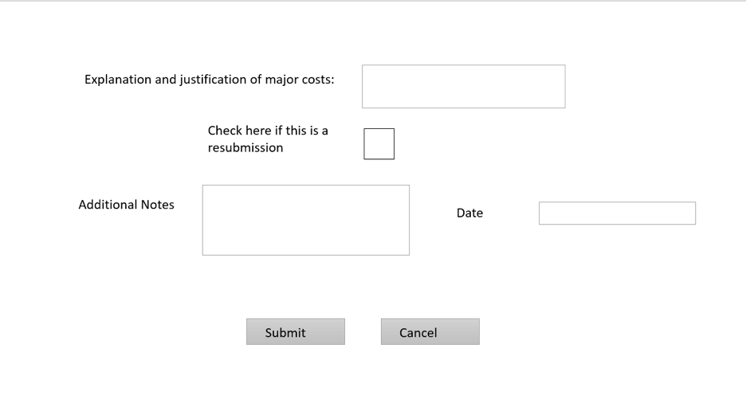

**Case 14-** Edit Funding Application(Researcher tab)

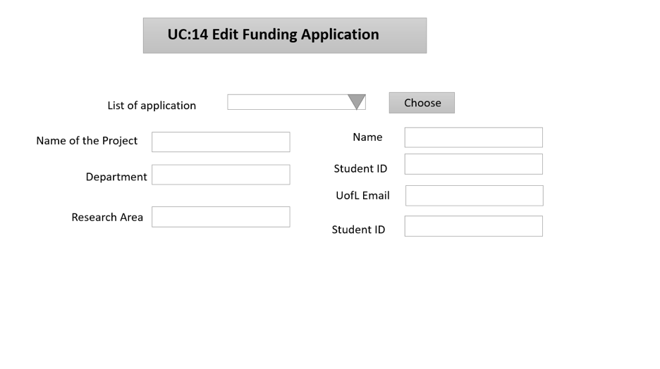

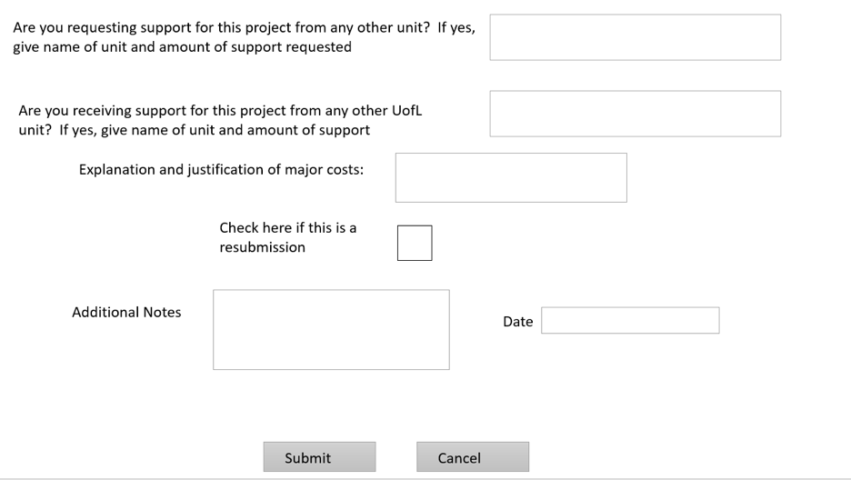

**Case 15-** Delete Funding Application(Researcher tab)

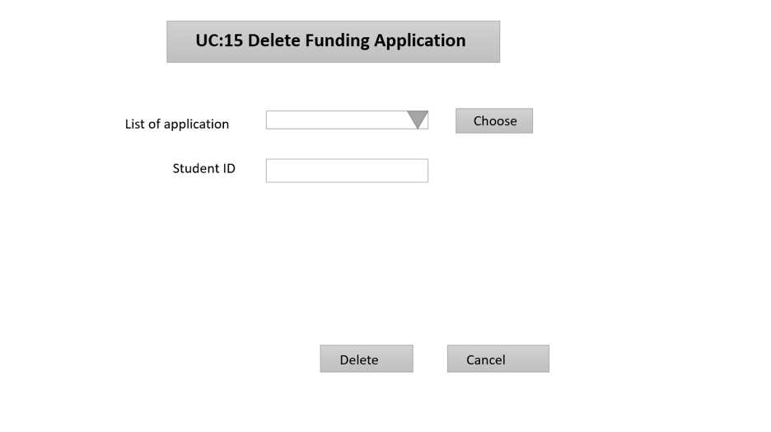

**Case 16-** Create Industry Proposal (Resources tab)

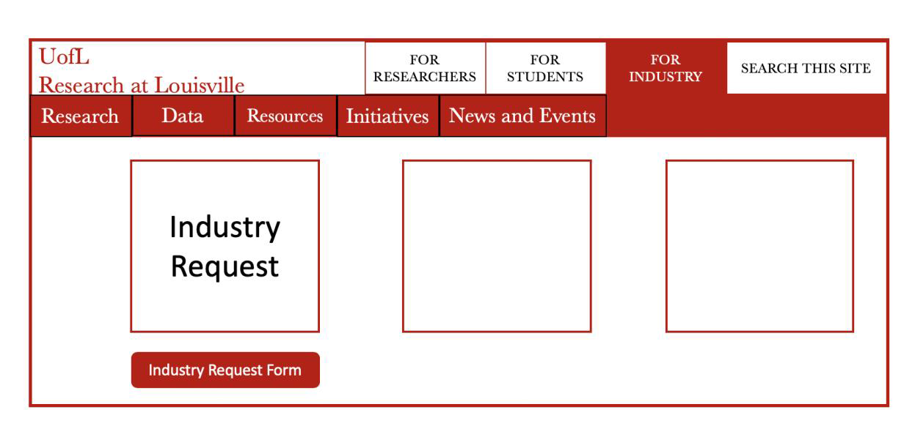

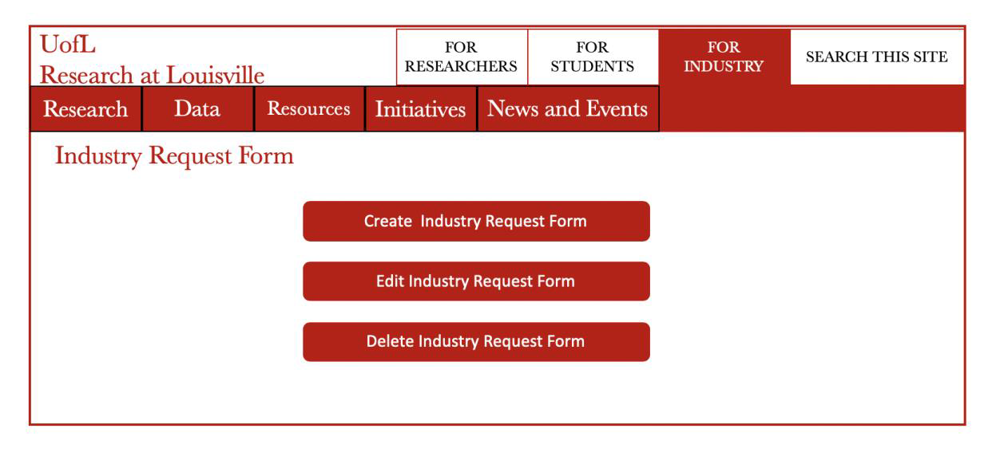

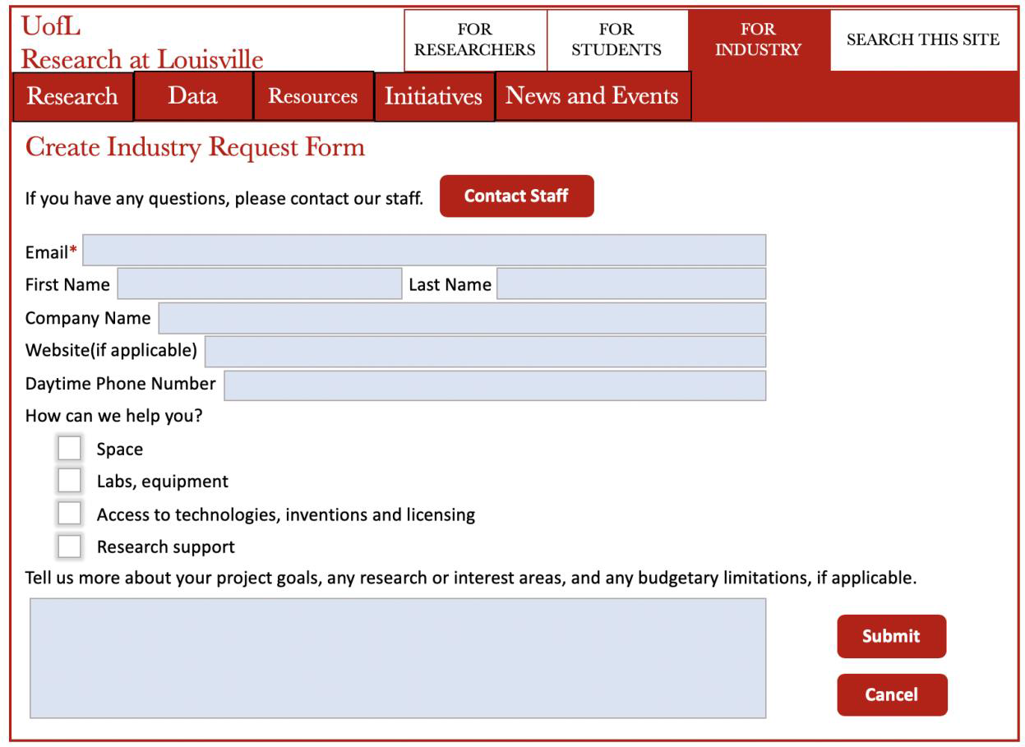

**Case 17-** Edit industry proposal(Resources tab)





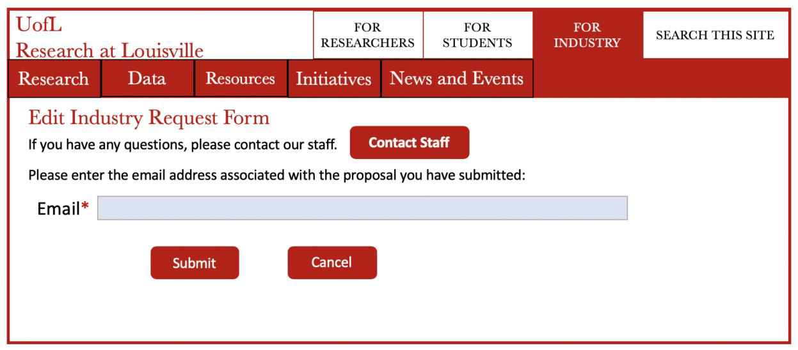

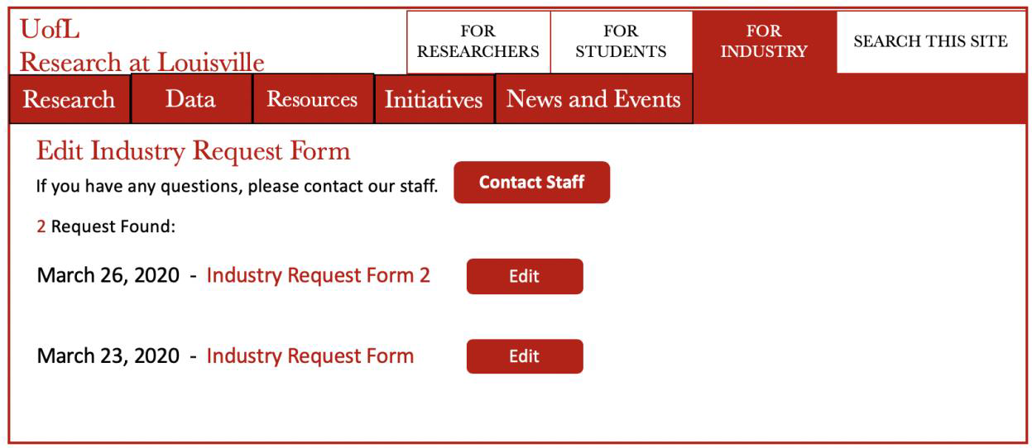

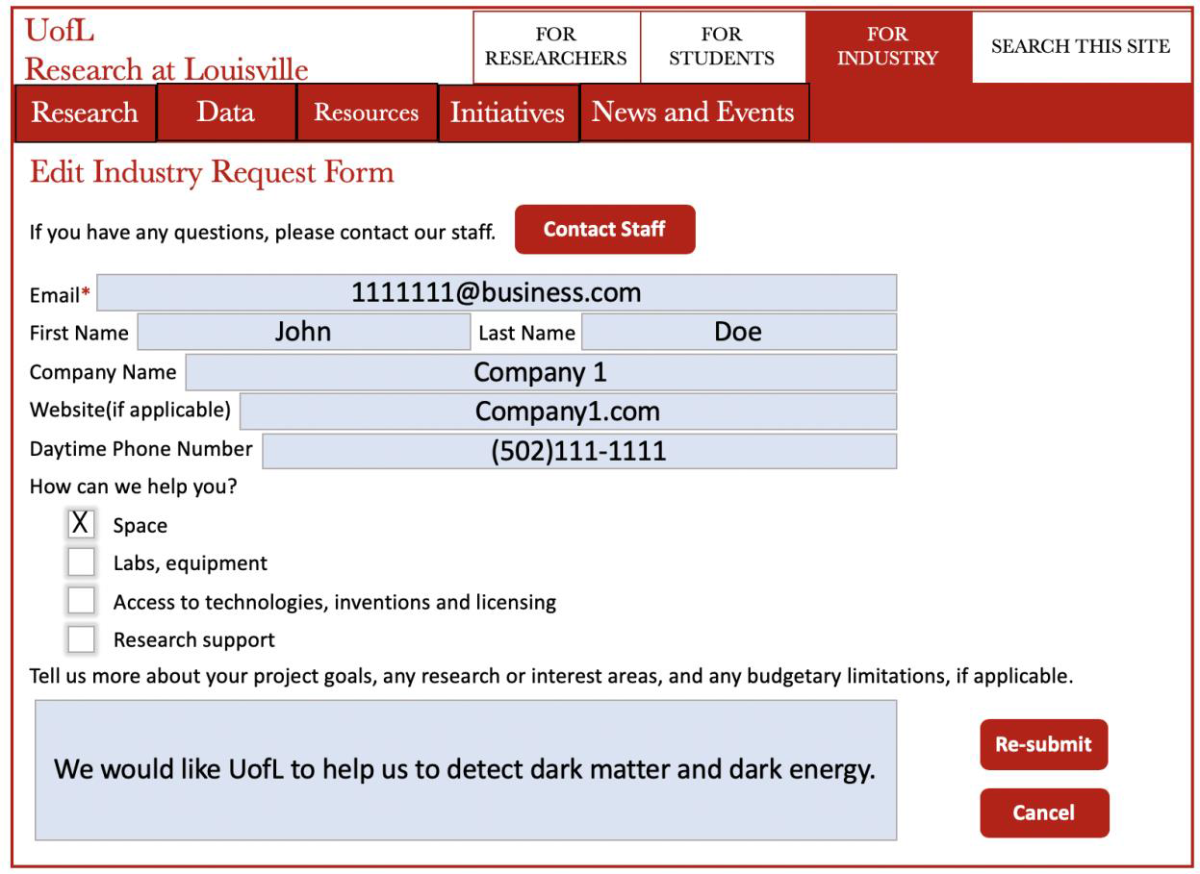

**Case 18-** Delete Industry Proposal



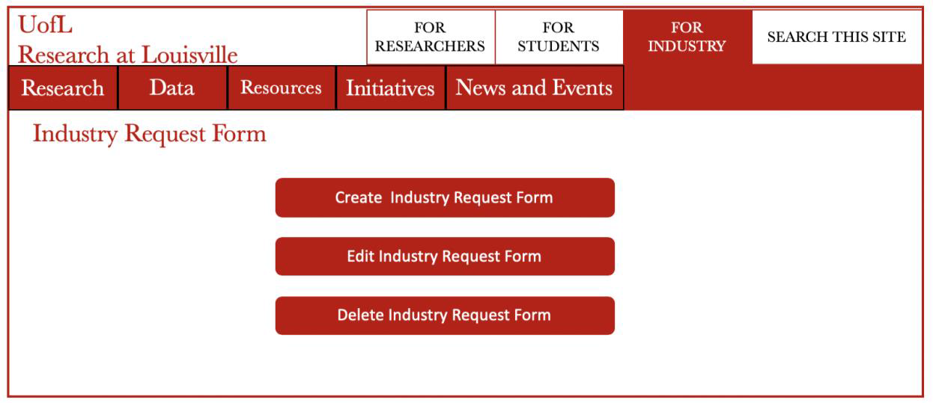

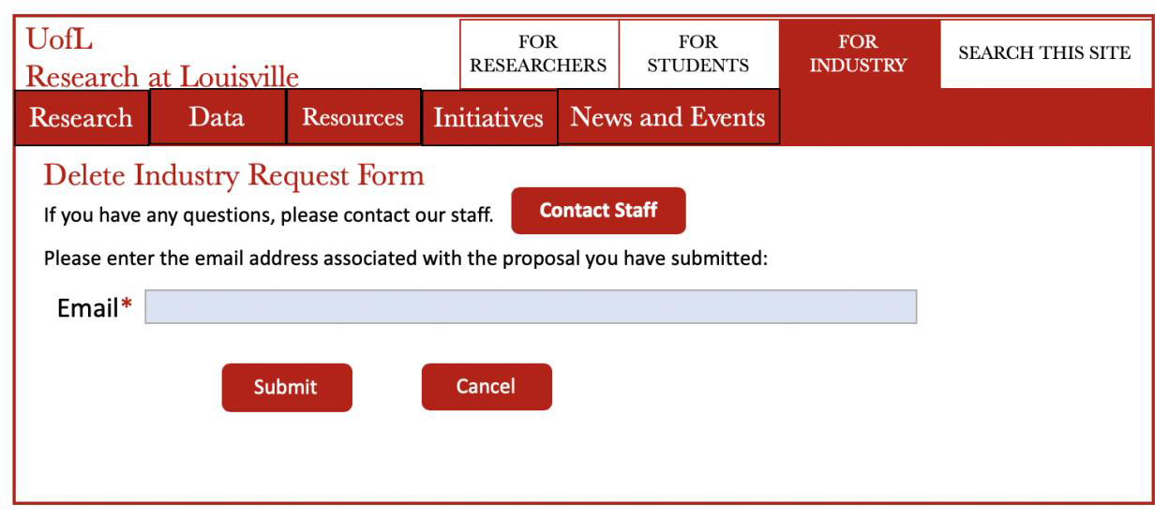

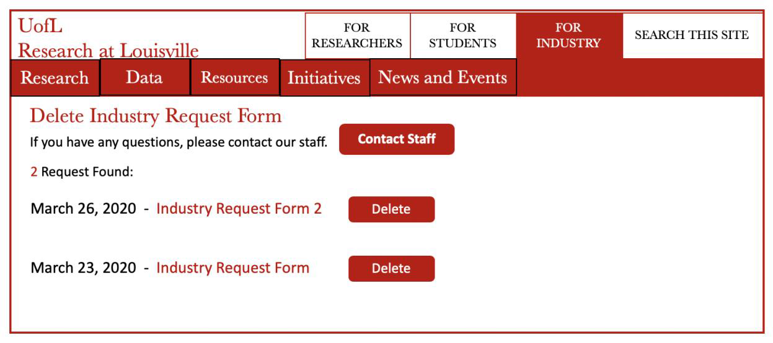

**Case 19-** Add Survey(Resources tab)

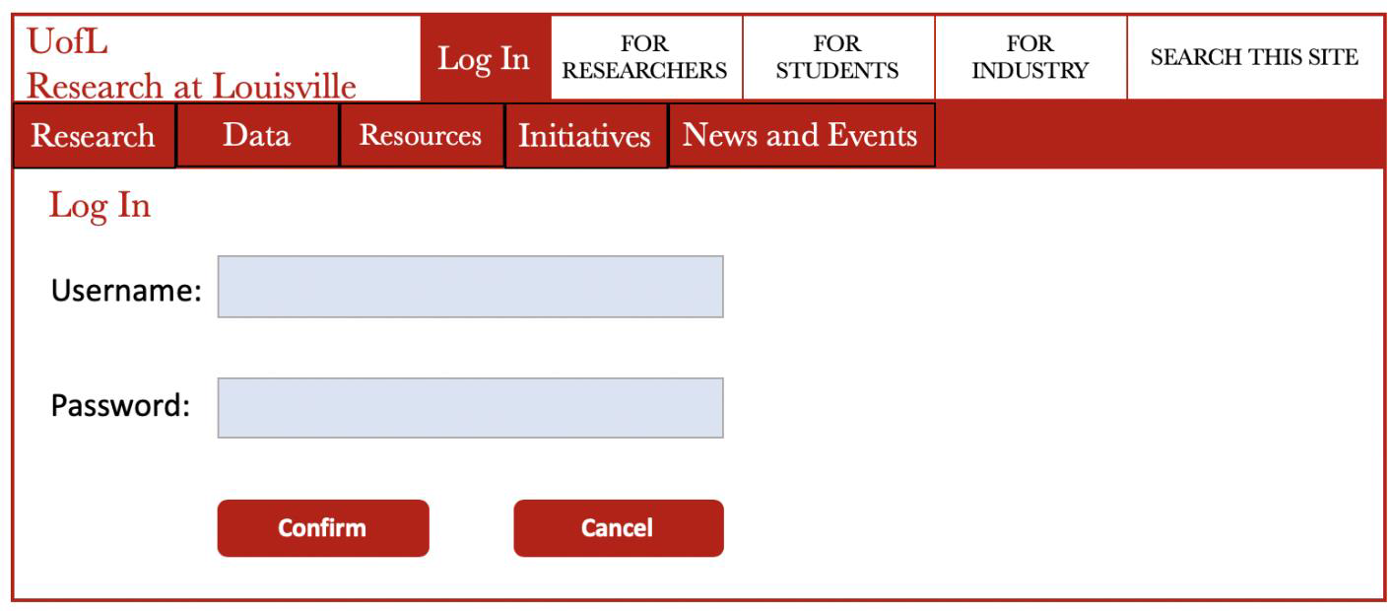

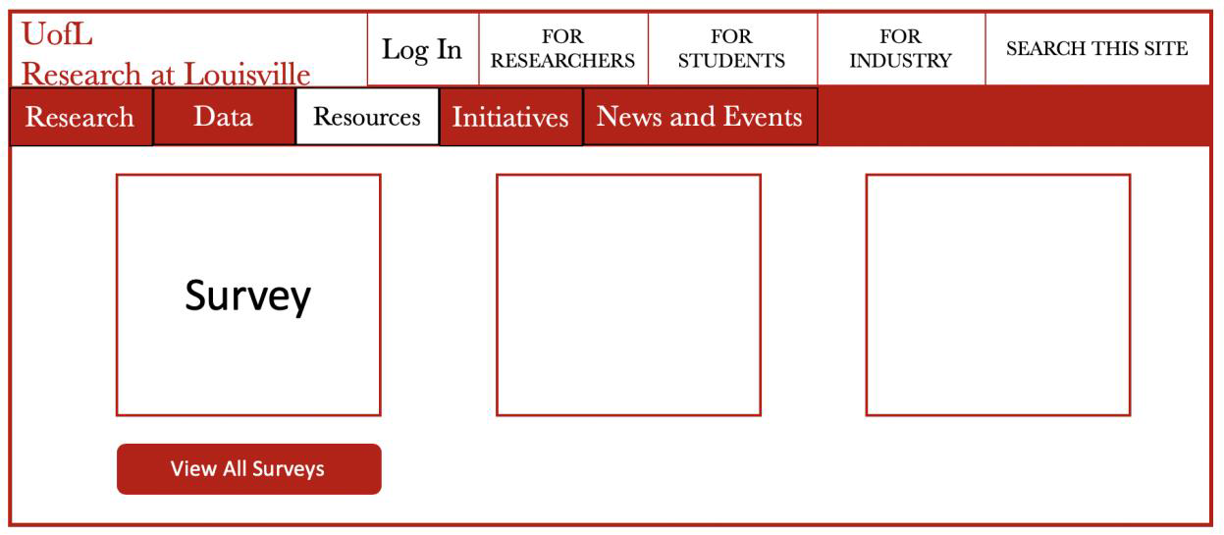

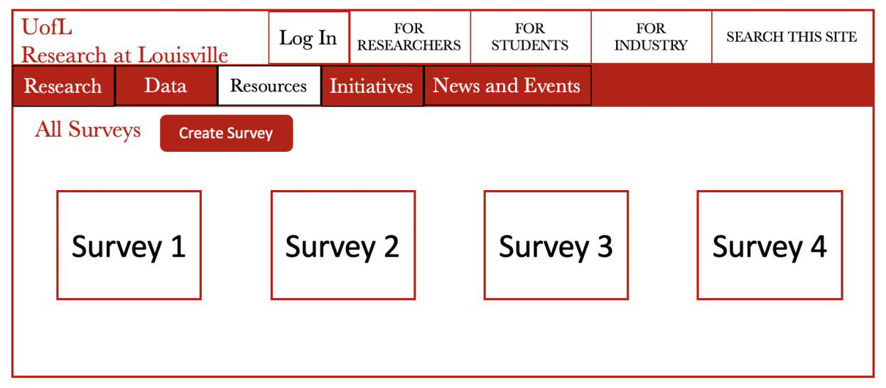

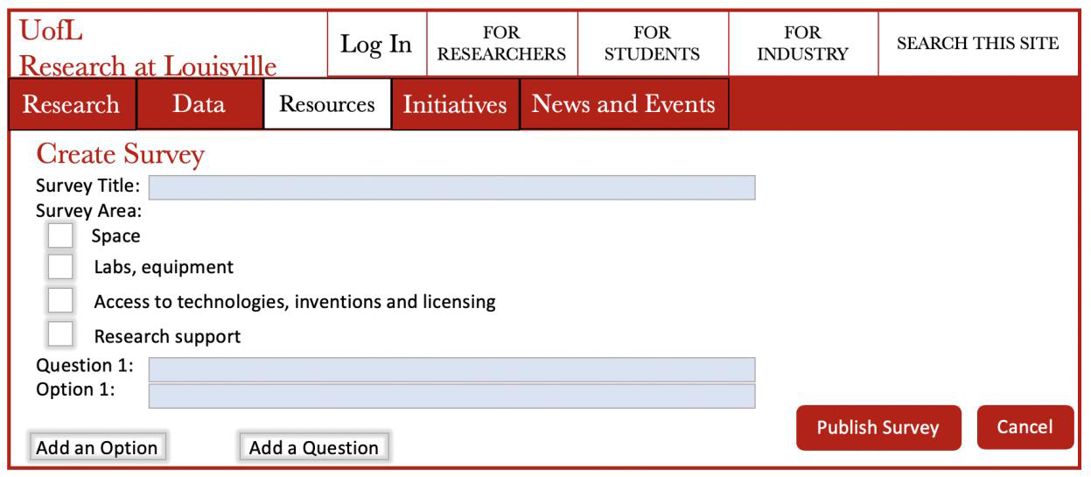

**Case 20-** Edit Survey(Resources tab)

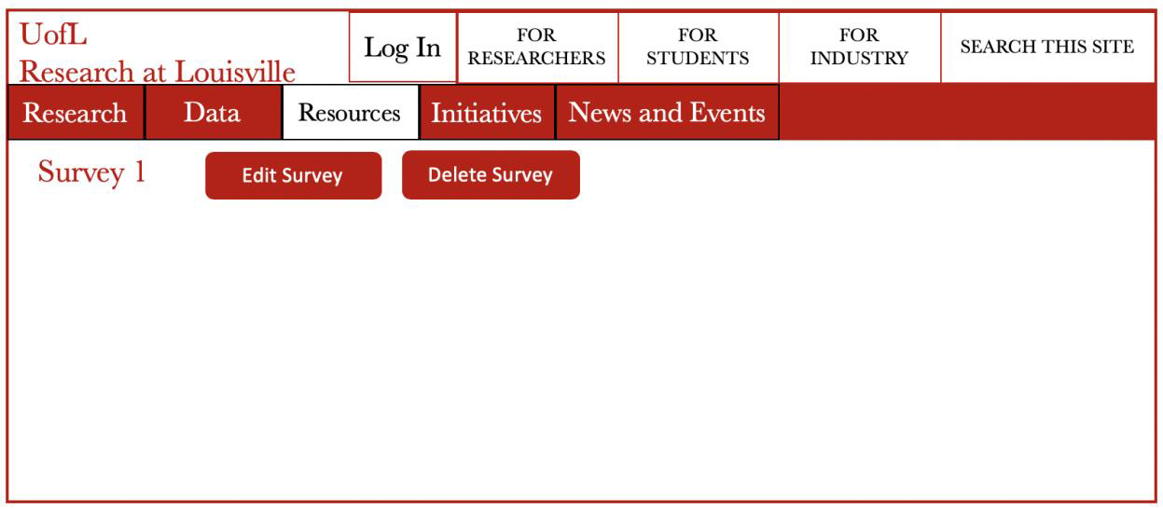

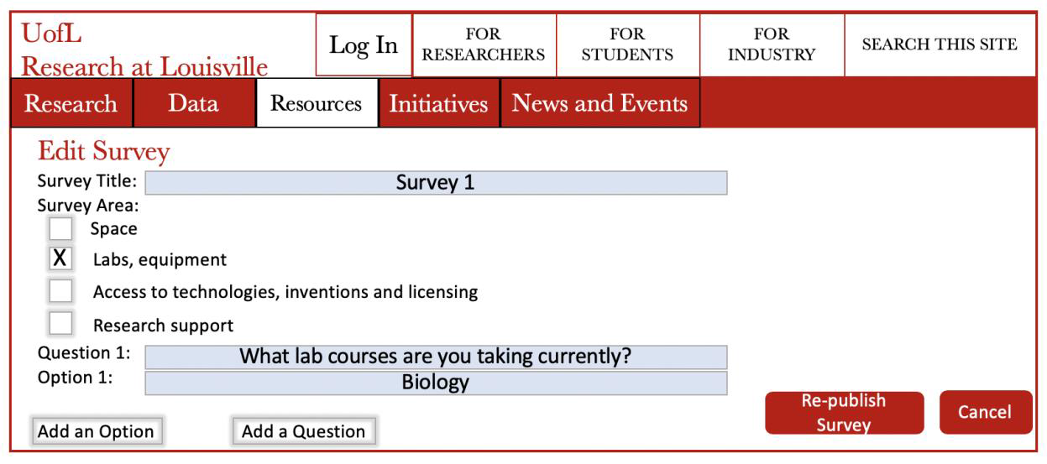

**Case 21-** Delete Survey(Resources tab)



**Case 22-** Login Form Admin

Homepage Top Left or Right

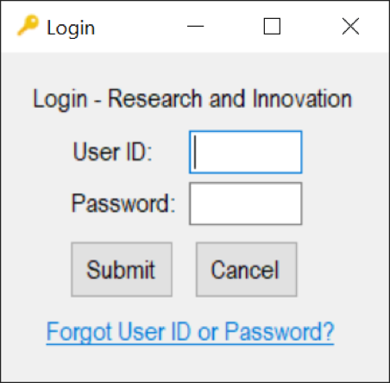

**Case 23-** Backup Data(Under admin profile?)

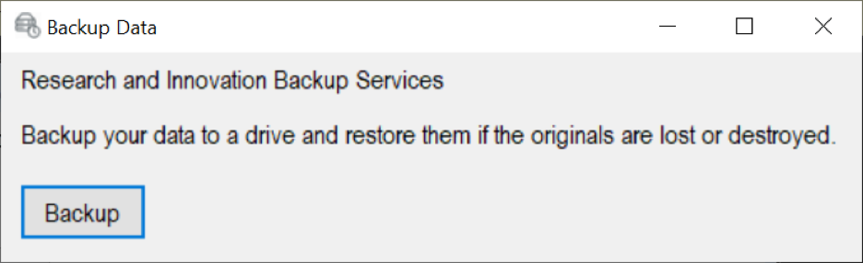

**Case 24-** Restore Data(Under admin profile?)

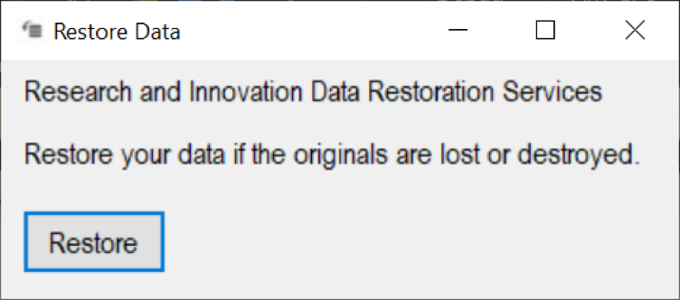

**Case 25-** Profile Form

Under a User Tab on top of homepage

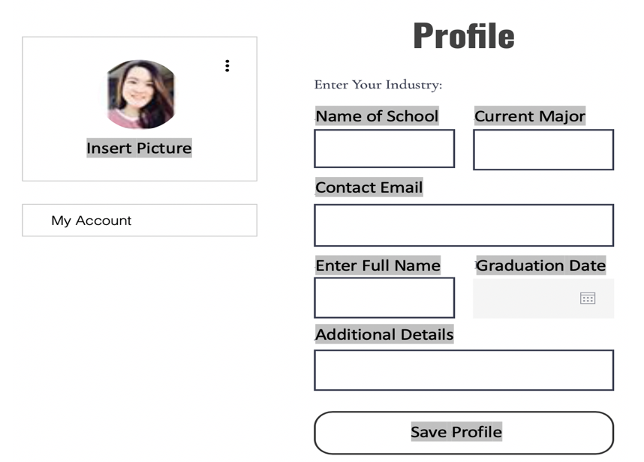

**Case 26-** Add Event Form

Under News & Events Tab

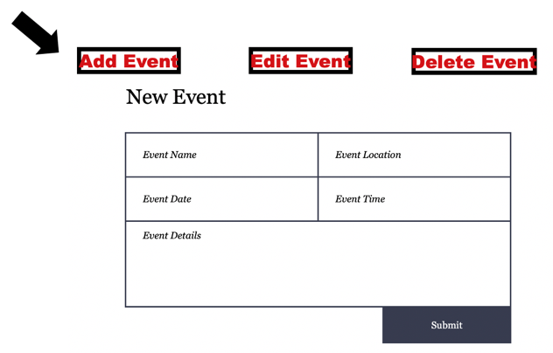

**Case 27-** Edit Event Form

Under News & Events Tab

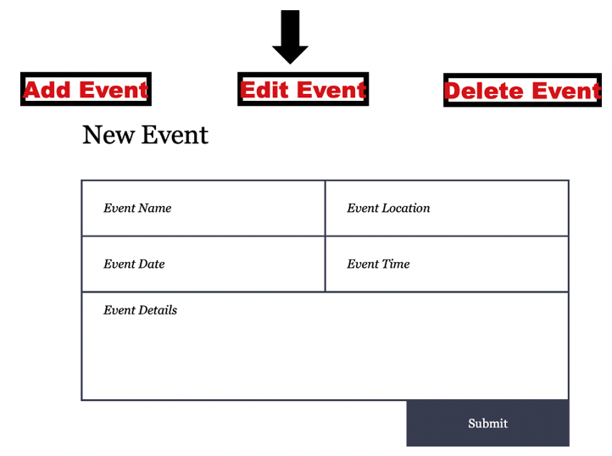

**Case 28-** Delete Event Form

Under News & Events Tab

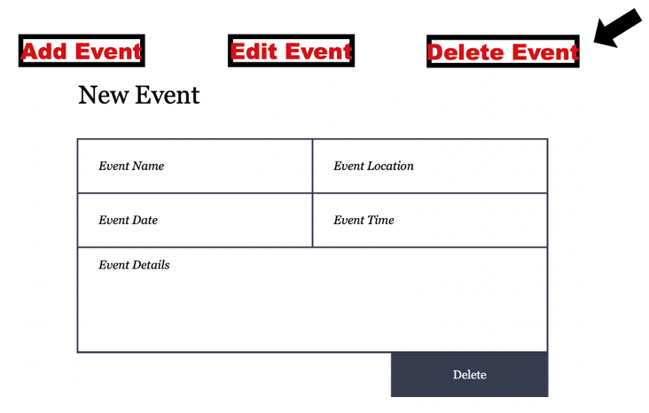

**Case 29-** Link the Donation Process Directly to UofL Development Departments (Resources tab)

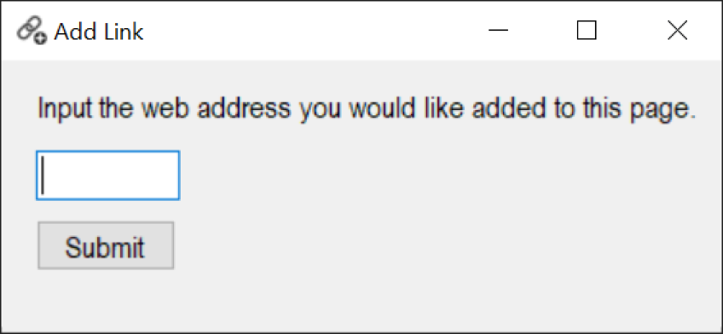

**Case 30**Link ThinkIR to Research Page Form( Resources tab)



**Case 31-** Login Student (Insert user icon on top left or right of homepage)

